Computer Networks (CS303)

Assignment - 2

**U19CS012**

**Understanding the concept of IP address, MAC address and port.**

**MAC address**

* A **Media Access Control** (MAC) address is a 48-bit (6 bytes) address that is used for communication between two hosts in an Ethernet environment. It is Hardware Address [Physical], which means that it is stored in the firmware of the network card.
* Every network card manufacturer gets a universally unique 3-byte code called the Organizationally Unique Identifier (OUI).
* Manufacturers agree to give all NICs a MAC address that begins with the assigned OUI. The manufacturer then assigns a unique value for the last 3 bytes, which ensures that Every MAC address is Globally Unique.

MAC addresses are usually written in the form of 12 hexadecimal digits. For example, consider the following MAC address:

**D8-D3-85-EB-12-E3**

Every hexadecimal character represents 4 bits, so the first six hexadecimal characters represent the **vendor** (Hewlett Packard in this case).

## How to find out your own MAC address?

If you are using Windows, start the Command Prompt (Start – Programs – Accessories – Command Prompt).

Type the **ipconfig /all** command and you should see a field called Physical Address under the Ethernet adapter settings:

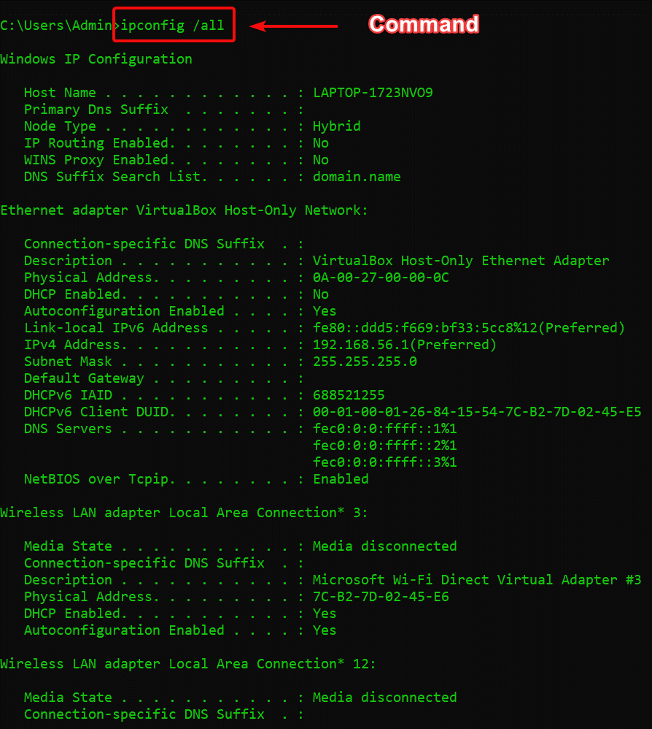

## IP address

* An IP address is a 32-bit number that identifies a host on a network.
* Each device that wants to communicate with other devices on a TCP/IP network needs to have an IP address configured. For example, in order to access the Internet, your computer will need to have an IP address assigned (usually obtained by your router from the ISP).
* An IP address is usually written in the form of four decimal numbers separated by periods (e.g. 10.0.50.1).
* The first part of the address represents the network the device is on (e.g. **10.0**.0.0), while the second part of the address identifies the host device (e.g.10.0.**50.1**).
* In contrast to MAC address, an IP address is a logical address. It can be configured manually or it can be obtained from a DHCP server.

NOTE:

The term IP address is usually used for **IPv4**, which is the fourth version of the IP protocol. A newer version exists, **IPv6**, and uses 128-bit addressing.

Private IP addresses

There are **three** ranges of addresses that can be used in a private network (e.g. your home LAN). These addresses are not routable through the Internet.

Private Address’s ranges are:

* 10.0.0.0 – 10.255.255.255
* 172.16.0.0 – 172.31.255.255
* 192.168.0.0 – 192.168.255.255

## How to find out your IP address

If you are using Windows, start the Command Prompt (Start – Programs – Accessories – Command Prompt). Enter the ipconfig command. You should see a field called IP Address:

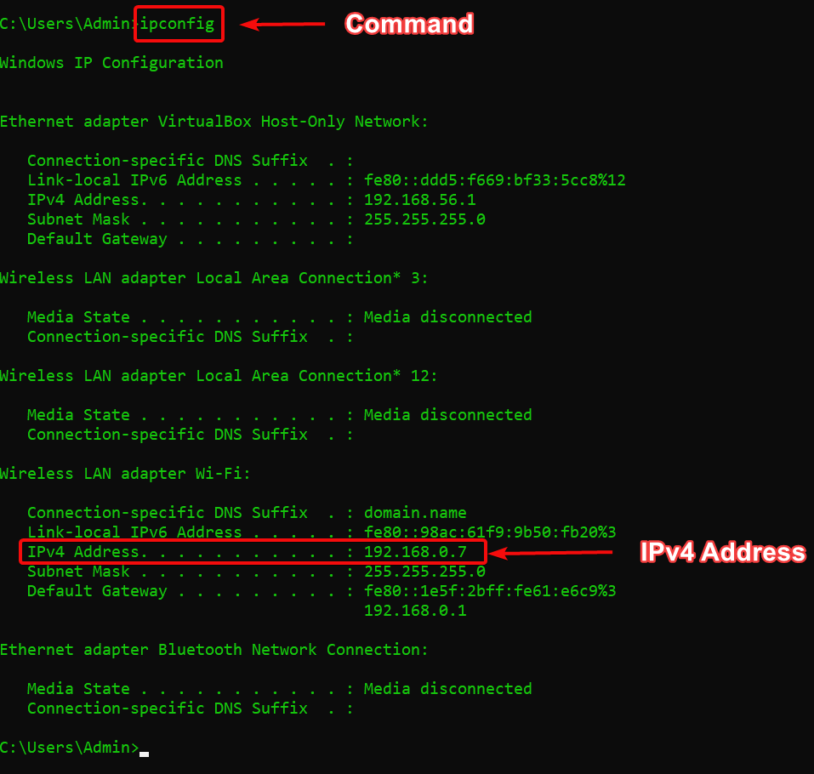

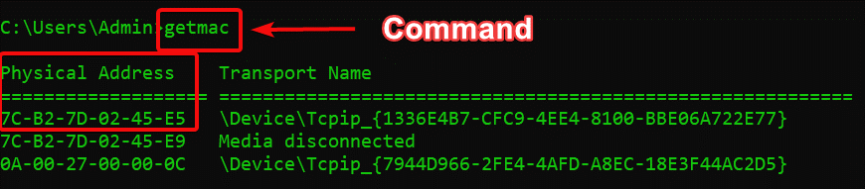

1. **Ping**

* Ping is a command-line utility, available on virtually any operating system with network connectivity that acts as a **test to see if a networked device is reachable**.
* The ping command sends a request over the network to a specific device.
* A successful ping results in a response from the computer that was pinged back to the originating computer

### How does Ping work?

* The Ping utility uses the echo request, and echo reply messages within the Internet Control Message Protocol (ICMP), an integral part of any IP network.
* When a ping command is issued, an **echo request packet** is sent to the address specified. When the remote host receives the echo request, it responds with an **echo reply packet**.
* By default, the ping command sends several echo requests, typically four or five.
* The result of each echo request is displayed, showing whether the request received a successful response, how many bytes were received in response, the Time to Live (TTL), and how long the response took to receive, along with statistics about packet loss and round trip times.

Example:

ping 168.93.37.2

ping ftp.microsoft.com

Google Public DNS IP addresses = **8.8.8.8**.

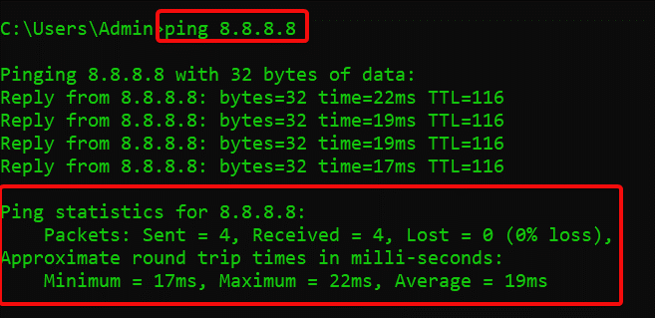

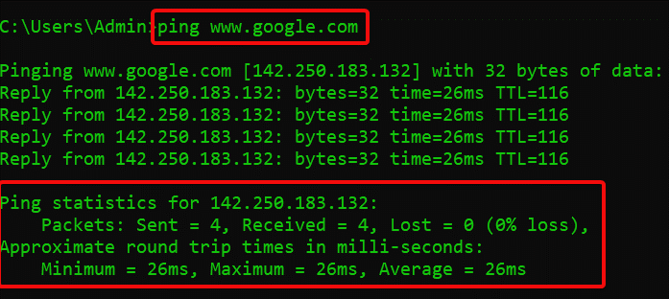

# Telnet

### What is Telnet?

* In a nutshell, Telnet is a **computer protocol** that was built for interacting with remote computers.
* The word “Telnet” also refers to the command-line utility “telnet”, available under Windows OS and Unix-like systems, including Mac, Linux, and others. We will use the term “Telnet” mostly in the context of the telnet client software.
* Telnet utility allows users to test connectivity to remote machines and issue commands through the use of a keyboard. Though most users opt to work with graphical interfaces, Telnet is one of the simplest ways to check connectivity on certain ports.

### Using Telnet to Test Open Ports

One of the biggest perks of Telnet is with a simple command you can test whether a port is open. Issuing the Telnet command **telnet [domainname or ip] [port]** will allow you to test connectivity to a remote host on the given port.

Issue the following command in the Command Prompt:

telnet [domain name or ip] [port]

Put the IP address or domain name of the server you’re trying to connect to in place of [domain name or ip], and replace the second brackets with the port number on the remote machine, connection to which you want to test.

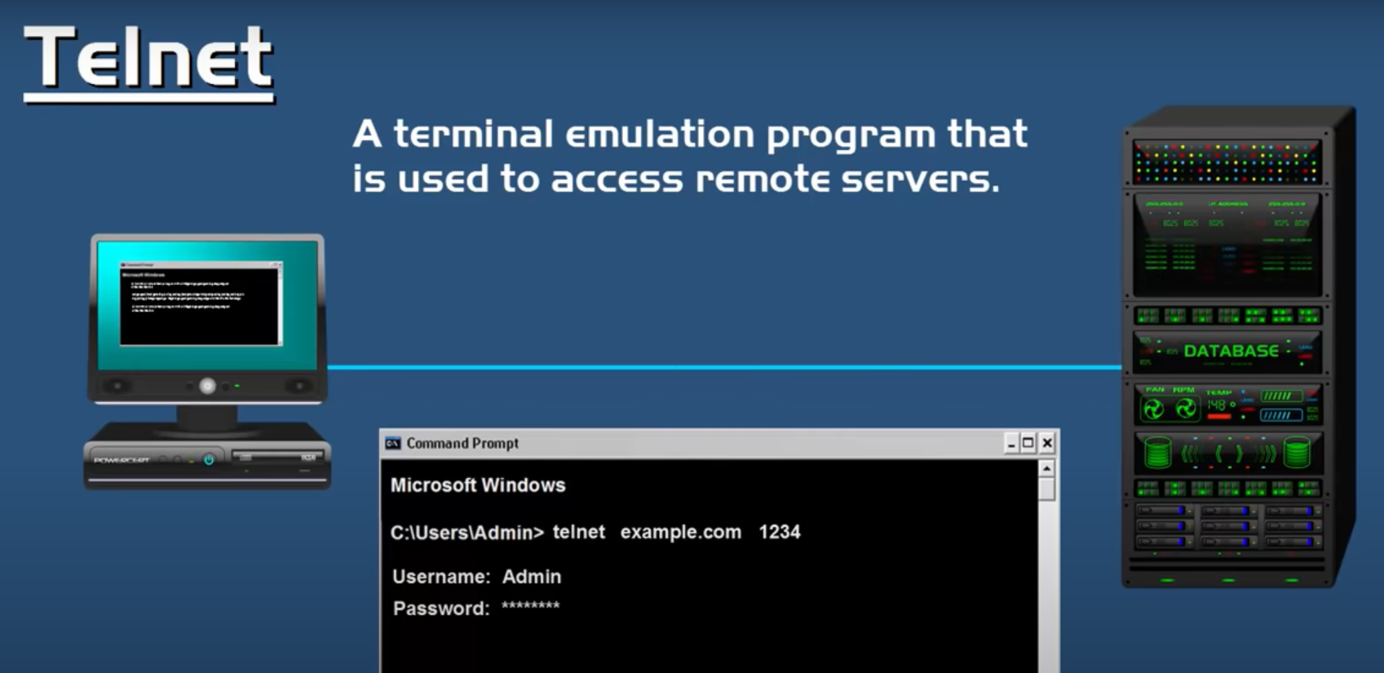

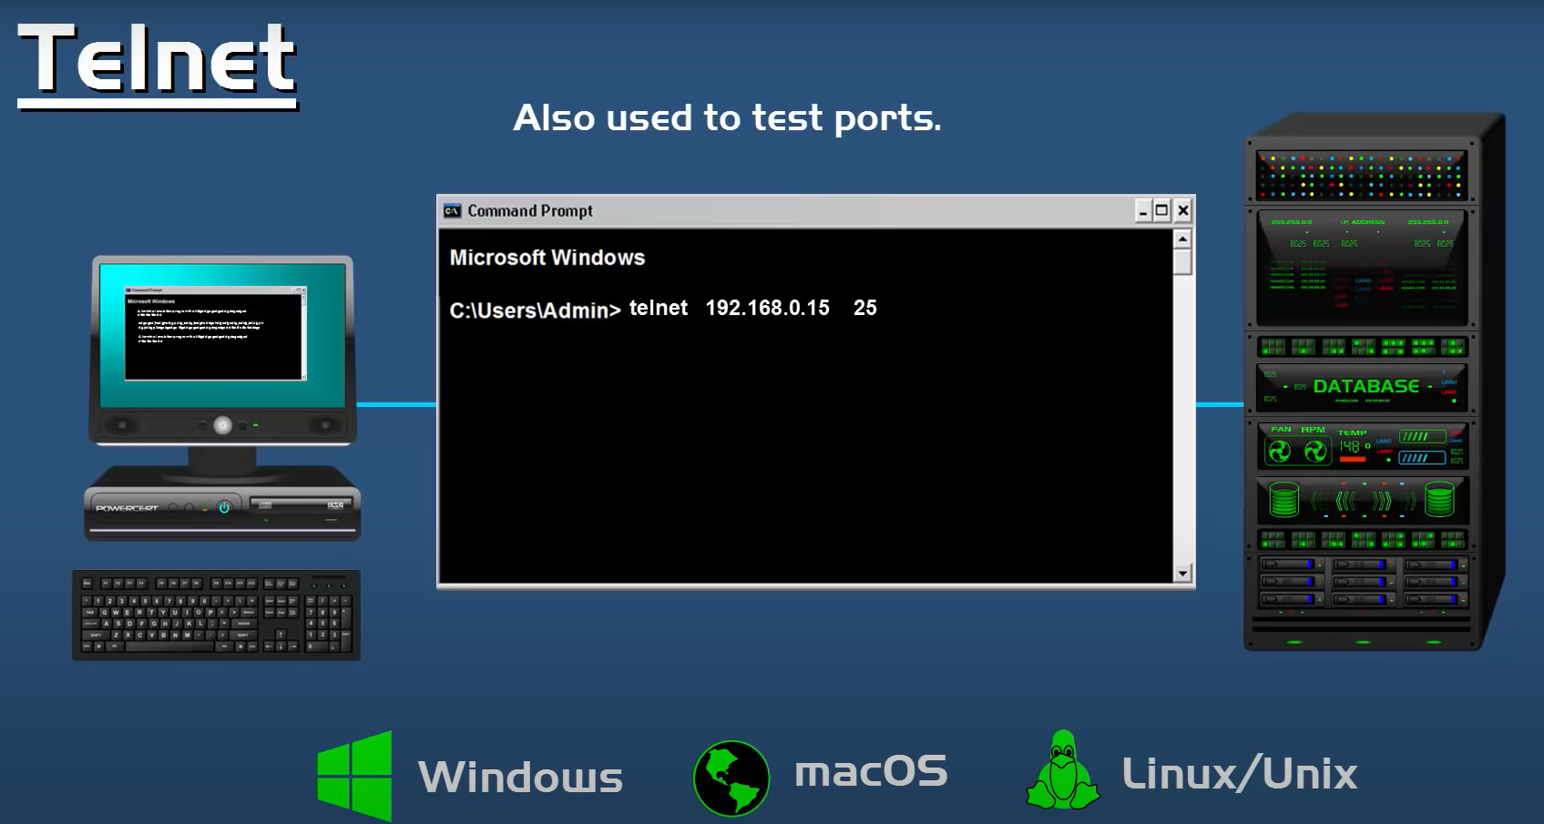

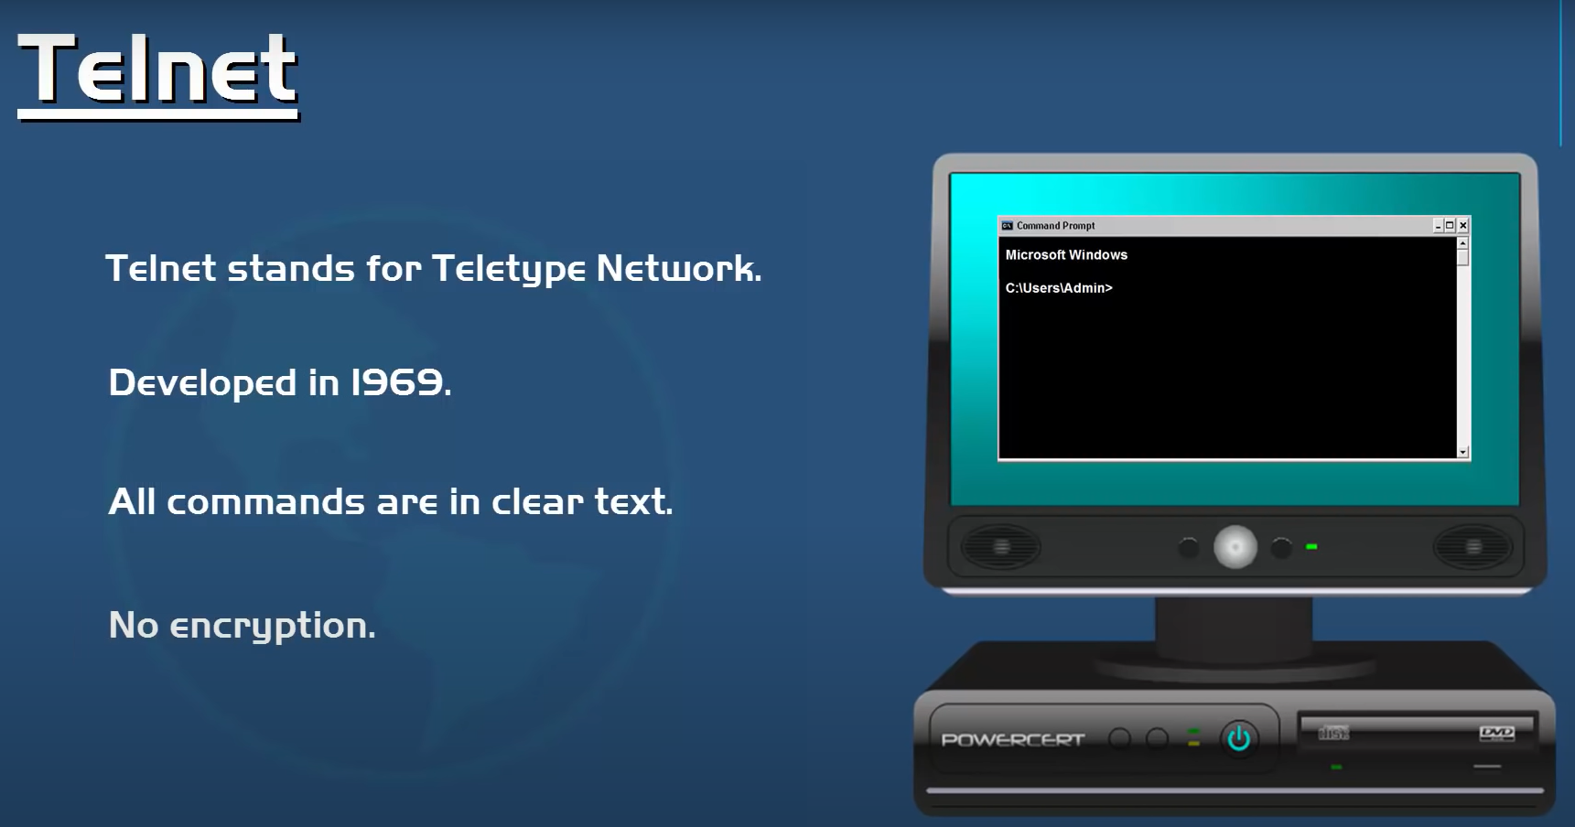

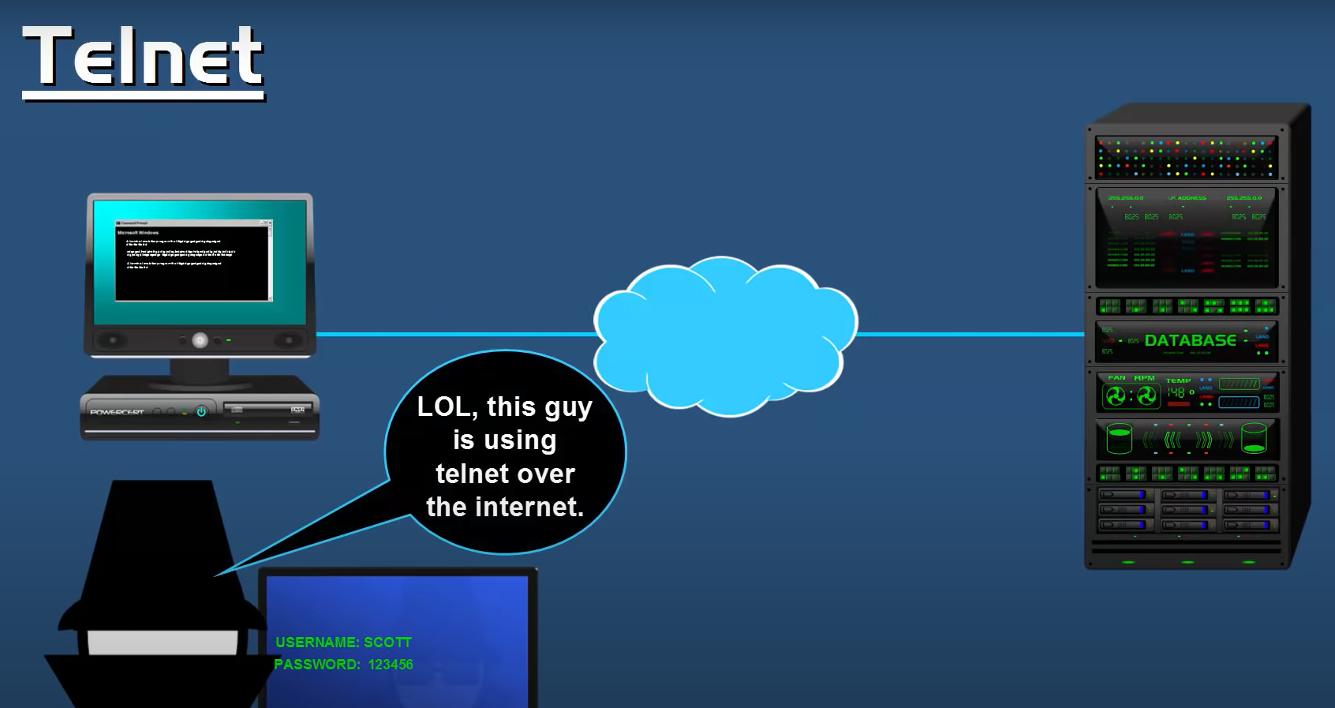

For example, to verify connection to 192.168.0.10 on port 25, issue the command: telnet 192.168.0.10 25

If the connection succeeds, a blank screen will show up, meaning that the computer port is open.

A failed connection will be accompanied by an error message. It can indicate either a closed port or the fact that the indicated remote server is not listening on the provided port.

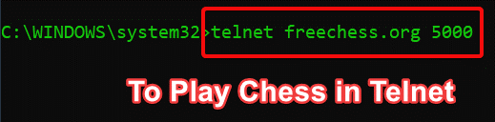

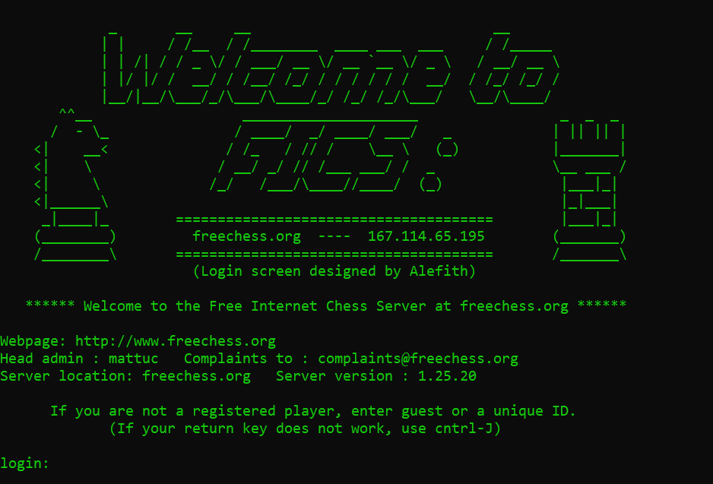

# Loopback

* A loopback address is a special IP address, 127.0.0.1, reserved by InterNIC for use in testing network cards.
* This IP address corresponds to the software loopback interface of the network card, which does not have hardware associated with it, and does not require a physical connection to a network.
* The loopback address allows for a reliable method of testing the functionality of an Ethernet card and its drivers and software without a physical network.
* It also allows information technology professionals to test IP software without worrying about broken or corrupted drivers or hardware.
* To test a network card using the loopback address, you can use the TCP/IP utility Ping.
* The best way to do this is with the Ping utility that comes with most operating systems.

This is a simple command-line utility that will try to communicate to an IP address.

Once you are at a command prompt, enter the following:

ping 127.0.0.1

If the command is successful, the Ping utility will return results similar to the following. The exact information returned will vary depending on your operating system:

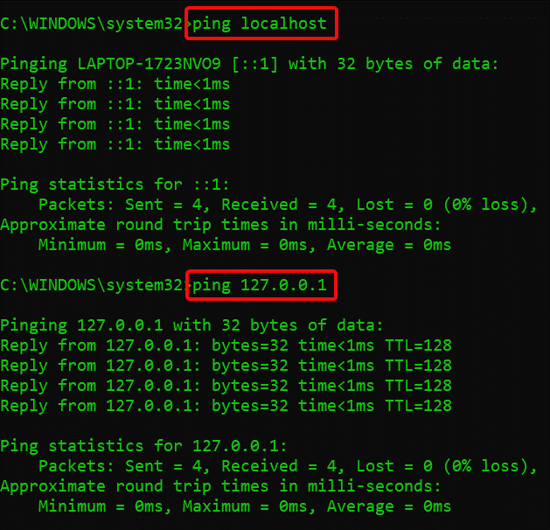

This indicates that the network card and drivers are functioning properly. If the Ping utility is not able to get a return on the network card, this may indicate either a driver problem, or a physical problem with the card.

SUBMITTED BY:

**U19CS012**

BHAGYA VINOD RANA